**PDA: Software Development**

**Level 8 – Student Evidence Checklist**

Name: Benjamin Robinson

Cohort: E22

**Week 2 – I&T – I.T 5**

Demonstrate the use of an array in a program, a function that uses the array and the result of the function running.

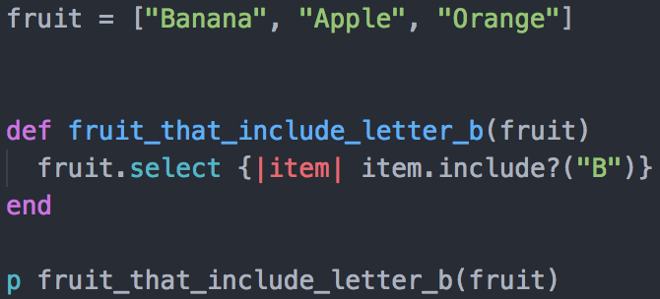



**Week 2 – I&T – I.T 6**

Demonstrate the use of a hash in a program, a function that uses the hash and the result of the function running.

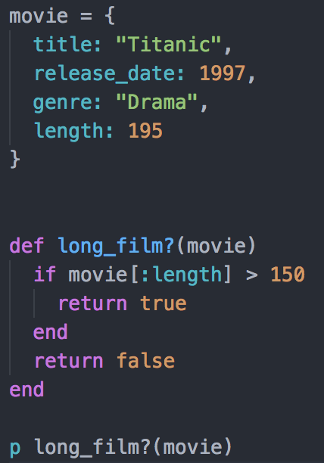



**Week 3 – I&T – I.T 3**

Demonstrate searching data in a program, a function that searches data and the result of the function running.

**Week 3 – I&T – I.T 4**

Demonstrate sorting data in a program, a function that sorts data and the result of the function running.